|  |
| --- |
| DooHee |
| 2D Platformer |
| **[RUNNING MAN]** |
| Version #1.3  All work Copyright © 2016 by DOOHEE Games.  All rights reserved. |
| **[DooHee Choi]** |
|  |



**Insert a Company Logo here**

|  |
| --- |
| Feb 29th 2016 |

**Table of Contents**

[Your Table of Contents should go here. Make sure that your document’s sections are hyperlinked to their corresponding pages.]

1. <https://github.com/doing84/Running-Man.git>
2. Dropbox on the eCentennial

**Version History**

[This is where you keep track of the detailed changes made to your document throughout the course of development.]

**Version Number 1.0**

-Feb.10.2016: Make plan, concept and methodology

-Feb.11.2016: Find source, audio, and BGM

-Feb.13.2016: Make some Block and Platform

**Version Number 1.1**

-Feb.20.2016: Hero Can move and jump

-Feb.23.2016: Make the structure of map

**Version Number 1.2**

-Feb.26.2016: Make the enemies (can move)

-Feb.28.2016: Fix some bugs or error

**Version Number 1.3**

--Feb.29.2016: Final test

[This is the body of your video game design document. You should add and delete sections as they pertain to your game’s design.]

1. **Game Overview**

*(ensure you mention the goal of the game and how to win if applicable)*

*The Hero should get coin with jumping and moving(avoid enemy)*

1. **Game Play Mechanics**

*(how does your game work?)*

*Move and Jump*

1. **Camera**

*(Point of View)*

*Fixed Camera View. 2D platformer Scroll action game*

1. **Controls**

*(Which keys does your game use? Does it use the mouse or a joystick?)*

*Keyboard only!*

*Play Game: Press Q key*

*Move: (Up, Down, Left, Right arrow keys) Or (Jump: W, Down: S, Left: A, Right: D*

1. **Saving and Loading**

*(Does your game include saving and loading? When? How?)*

*This game does not provide save and load*

1. **Interface Sketch**

*(What does the game interface look like? Provide a screen shot or sketch)*

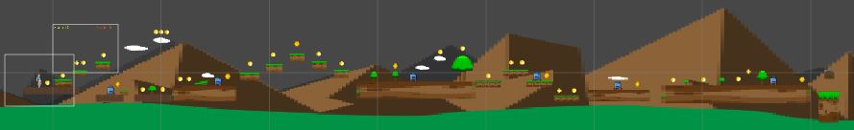

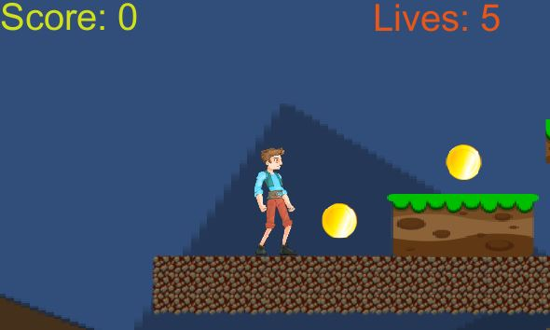

1. **Menu and Screen Descriptions**

*(Include additional screen shots and accompanying descriptions for any menus and additional screen)*

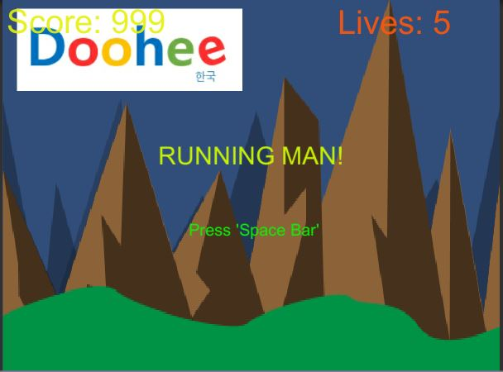

1. **Game World**

*(Describe Your Game Environment)*

Escape! In this land!

1. **Levels**

*(Describe Each of your game levels)*

*Obstacle 1: Just land*

*Obstacle 2: Cube*

*Obstacle 3: Cloud*

*Obstacle 4: Tree*

*Obstacle 5: Enemy*

1. **Game Progression**

Game progression is run from left direction to end of right direction

1. **Characters**

*(Describe Your game avatar if applicable)*

*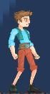Hero*

1. **Non-player Characters**

(Describe Any Computer controlled Allies and how they work)

It does not have allies

1. **Enemies**

*C:\Users\user1\Desktop\enemy.JPGEnemy*

1. **Weapons**

*(Describe any weapons available to the user)*

This game does not provide script. Just run!

1. **Items**

*(Describe any in-game items that can help or hinder the user)*

No item, it is little bit hard game!

1. **Abilities**

Run and Jump

1. **Vehicles**

Nothing

1. **Script**

This game does not provide script

1. **Scoring**

C:\Users\user1\Desktop\coin.JPGCoin: 10

C:\Users\user1\Desktop\bonus.JPGBonus: 50

1. **Puzzles/Mini-games**

This game does not provide puzzles/mini-games

1. **Bonuses**

Get the Bonus Coin!

1. **Cheat Codes**

No cheat

1. **Sound Index**

*(Include an index of all your sound clips)*

Jump effect: jump.mp3

Death effect: death.mp3

Get Coin effect: coin.mp3

Background music: Yoko Kanno Compilations Vol. 1 - Dreaming of You - Take to the Skies.mp3

1. **Story Index**

*(Outline your game story here)*

You should escape from this land

1. **Art / Multimedia Index**

*(Include an index of all your graphic and video assets here)*

1. **Design Notes**

*(Include additional design notes here)*

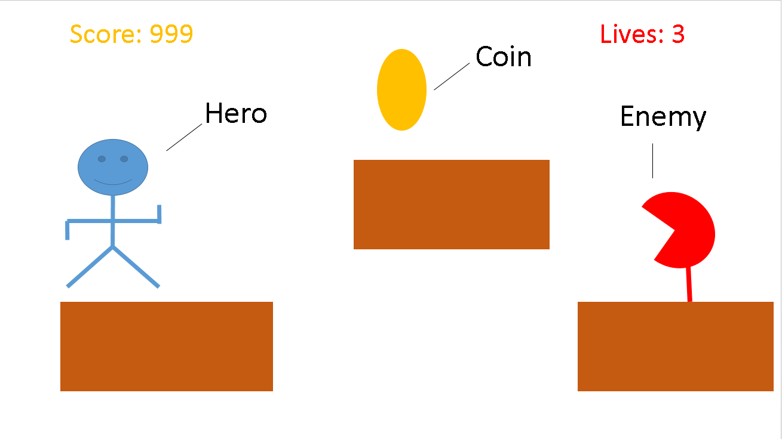

1. **Future Features**

*(Include any future features that are planned to be implemented)*

1. *Various enemies*
2. *Can choose Character*
3. *Can play next stage*